X00109563 – Gavin Hickey

Exploration/Requirements

Friday 12th February

3rd Year Project

2D Unity Video Game

Gavin Hickey – X00109563

Overview

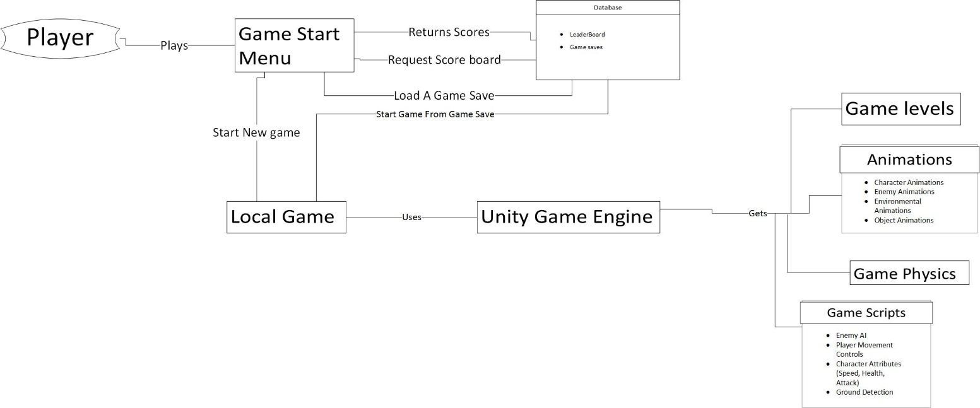

Our Project will be side scrolling platforming video game, this game will be built in unity and be taking inspiration from different 2d games some retro and other more up to date. The style of the game follows an old retro pixel look like many arcade titles of the past. The game its self will be a platforming game where the player must navigate through the level while overcoming obstacles and defeating enemies. Each level will be personally designed and the difficulty will range depending on each level and the players own choice before the start of each game. The levels will be designed in a way for them to be enjoyable and non-repetitive so as to keep them interesting and fun to play. The game will be using Unity as its game engine which will get the animations for each needed object whether it be players or enemies, Unity will also be used to operate scripts that will be written in Visual Studio for more complicated functions like enemy AI, ground detection and player attributes, Unity also supplies its own game physics and can be used to design the game levels.

The game will have assets that will be designed by us using various programs, such as the design of the characters animations and look using Photoshop CC and the use of audacity to improve the audio tracks and effects. These designs will be linked and used by the animator in Unity to function as animations of the character enemies and parts of the environment.

The games menu will be a simple design so that the user can easily navigate and use without become frustrated and getting into the game with a negative mind set. There will options to mute the audio of the game and also to change the difficulty and load different saves of the game allowing the user to play from the start or continue on from a different point where they left off. The menu will link to the game when the start button is selected or when a save of the game is loaded in from the database.

The game will offer and leader board so that players can achieve high scores and also to give the game a more arcade like feel to it. The leader board will be assessable to view through the main menu. This leader board will be stored in a database and used to keep track of peoples scores, being updated and changed with each score. The leader board was chosen to be included so that other players of the game can compare their scores and have a fun times challenging each other to beat won another at getting a higher score.

At this current point in time we will have a working prototype being used as a tester level to test the dynamics of the game so far and also work as a way to help test the game alongside the game testers to plan out levels in the future in order to ensure fun and creative levels that offer a good balance in difficulty and functionality.

Target Audience

Our target audience is anyone who enjoys and has a passion for video games, especially those with a particular like of old school retro games. We aim to create a game that is fun to play as we don’t believe in having a big focus of aesthetics because we think that having better gameplay than visuals, this is one of the main reasons we have chosen the retro pixel game look. We have seen in the past that this idea hold true with many new game out that offer a fun gameplay experience even though there graphical design is not that same as bigger game titles.

There are still gamers out there to this day who choose to go back to older game titles to relive them or even discover them through their reputation and this is due to their popularity because of how fun they were to play and this is why we are targeting those gamers out that base a games merit of the gameplay and enjoyment they get out of playing it. Being gamers ourselves we know the different titles out there, the different game genres and styles and found that retro style games have not lost their popularity.

The game will be a platforming game with element inspired by other titles for example the beat’em up style game of “Scott Pilgrim Vs. The World” this means there will be a mix of gameplay and allowing the game to not stay too plain and become repetitive and lose the players interest. The levels will be designed with the help of game testers so that they will help capture the users attention, while remaining challenging and enjoyable.

The music will be designed to be an old style techno type of sound. This will also be inspired from older game titles like Super Mario Bros. This is to keep with the retro game vibe that we want to instil while playing. We chose this because we believe it suits the game more.

The games design will be influence through our own tastes and ideas but we will be working along other gamers , this being the game testers, so that we will gain the opinion of a larger crowd so that we can make the game more pleasing and make people want to play. The design of the game will be designed on what we think people will enjoy be will also to changed and altered by the game testers opinions to broaden our vision of what we think people will enjoy even though we will still stress the idea of gameplay over the visuals.

|  |  |  |  |
| --- | --- | --- | --- |
| **ID: (1)** | **Story Title: Character Movement** | **Priority: (2)** | **Estimate:**  **4 hours** |
| As a Player I want use different buttons so that I can move the player character in different directions that correspond to the buttons I press, i.e pressing the right arrow key or the D key to make the character move right or hitting the space bar to make the character jump up. | | | |

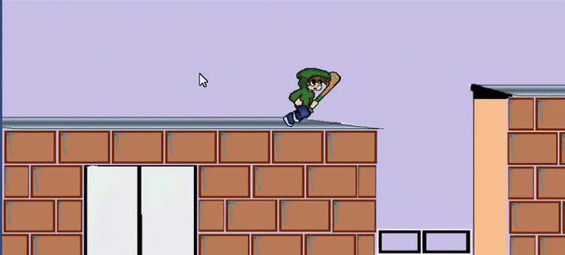

*Above is the character in movement*

**Movement Confirmation:**

1. **Success** – User Moves Character
   1. User presses a button to move the player character
   2. Character moves to the according button being pressed
2. **Failure** – Character does not move
   1. User presses a button to move the player character
   2. Character remains in place and is unresponsive to the users input

|  |  |  |  |
| --- | --- | --- | --- |
| **ID: (2)** | **Story Title: Ground detection** | **Priority: (4)** | **Estimate:**  **1 hour** |
| As a Player I want the player character to be able to stay on a platform so that I can have platforms to jump to and not fall through them. | | | |

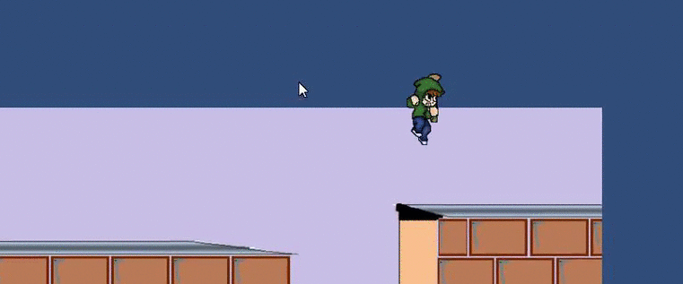

*Above is the character in the falling state*

**Movement Confirmation:**

1. **Success** – Character detects ground/platform
   1. The game starts
   2. The character does not fall through a platform or ground
   3. Character can move from platform to platform without falling through them
2. **Failure** – Character falls through the platform
   1. The game starts
   2. The character falls through the environment
   3. Character continues to fall infinitely due to there being no ground to connect to

Release Plan

|  |  |  |  |  |
| --- | --- | --- | --- | --- |
| Iteration | Stories | Duration | Start Date | End Date |
| 1 | ID:  1, 2, 3a 3b | 21 Days  (aiming for 19) | 13th February 2016 | 4th March 2016 |
| 2 | ID:  4, 5, 6a, 6b, 7 | 29 Days  (aiming for 10) | 5th March 2016 | 3rd April 2016 |
| 3 | ID:  8, 9, 10, 10a, 11 | 28 Days  (aiming for 20) | 4th April 2016 | 1st May 2016 |

|  |
| --- |
| ID 1: Main Menu |
| ID 2: First Level |
| ID 3a: Enemy AI |
| ID 3b: Character Animations |
| ID 4: Power Ups |
| ID 5: Score Board |
| ID 6a: Level 2 |
| ID 6b: Questionnaire for testers |
| ID 7: Subsequent Level Development |
| ID 8: Boss Battles |
| ID 9: Combo Moves |
| ID 10a: Game Completion |
| ID 10b: Complete Documentation |
| ID 11: Practice Presentation |